LMS Demo

To sign in in to your account use this link <https://intellvisionacademy.com/intell_login/>

After signing in to the system <https://intellvisionacademy.com/wp-admin> will take you to the dash board

**Adding courses, Lessons and Topics to LMS**

**Adding course**

To add course, go under Learndash LMS and click courses

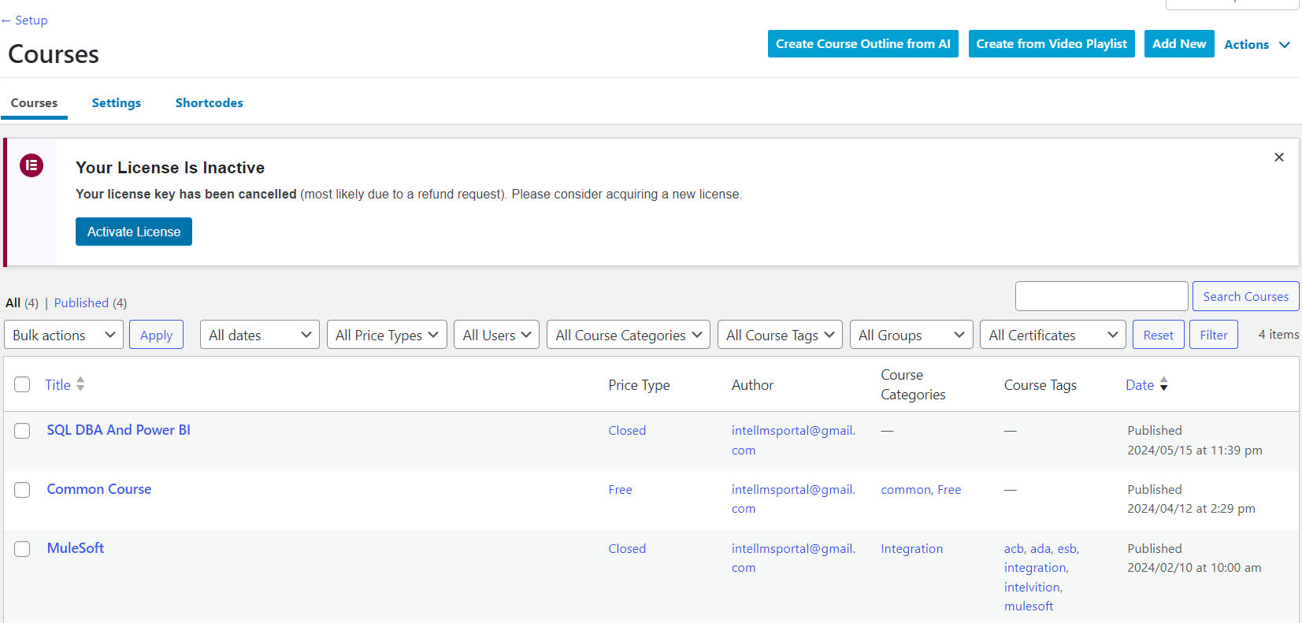

* Click add new from right Top corner
* Once you open, you will see a course title. give course title and click publish.

**Adding Lesson**

to Add lesson to our course, click lessons under Learndash LMS

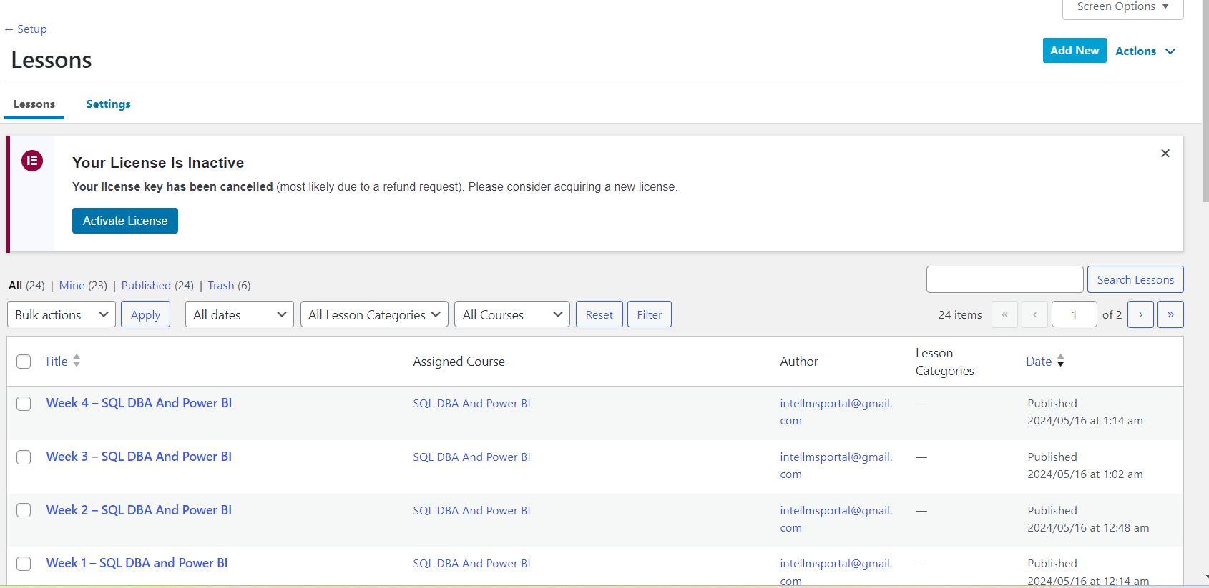

* After clicking add new, give lesson title it should start with **Week 1 – title**
* Then go to settings
* Set associated course 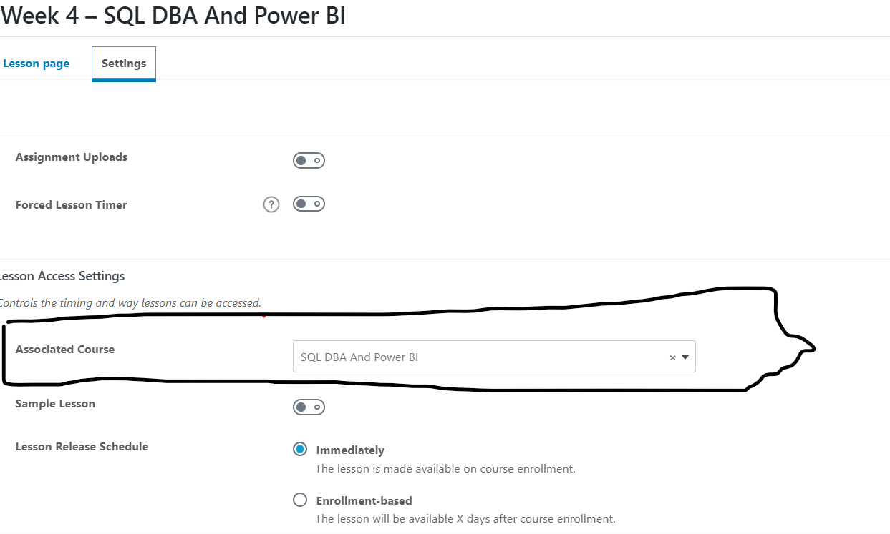

**Adding topics**

* To add topic for the lessons we set formerly go under Learndash LMS and click topics
* We need to add two main contents under topics those are : **power points** and **recordings**
* To add power points we use canva as storage and embed html items ,
* To do that copy html embed item from canva and go back to lms topics
* Click add content and select custom HTML and paste the item from canva .

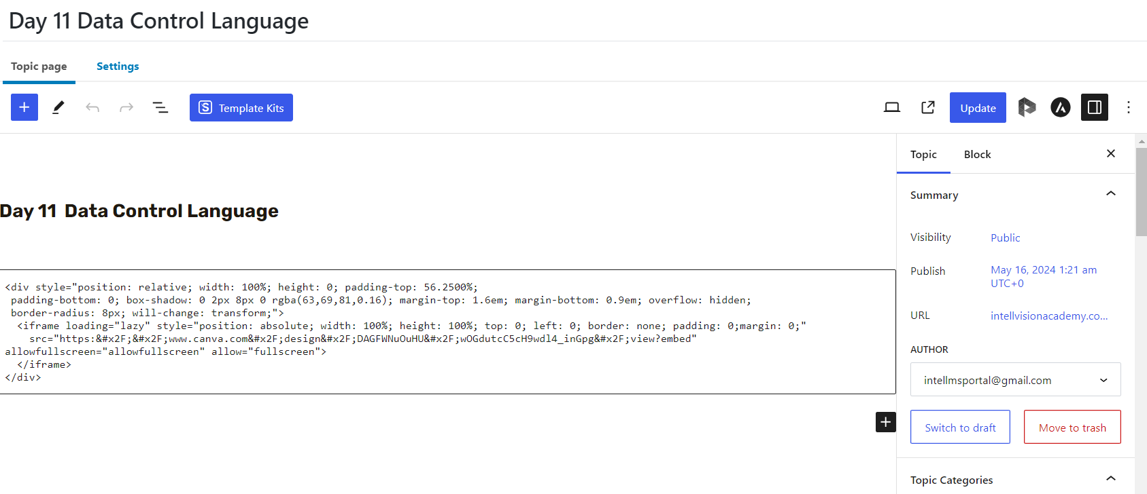

After pasting item go to settings and select **Associated course** and **Associated Lesson**

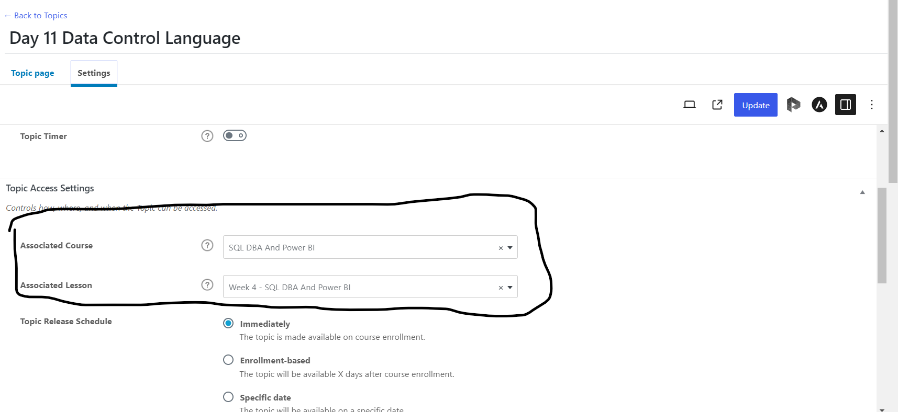

* To add **videos,** go to our google drive and open the video and take embed items of the video, go to under topics, click add content ,select custom HTML and paste it

Then click publish.

**N.B** All the above courses and course contents are editable.

To understand further about the LMS Plugin you can use the link blow and explore the user guide

<https://www.learndash.com/support/docs/guides/>